BALBARDIE PRIMARY SCHOOL
Torphichen Street, Bathgate, EH48 4HL
Tel: 01506 652155
Mrs Margaret Johns – Head Teacher

Dear Parent/Carer,
From 8th-12^{h} of June we are delivering a Home Health Week for our pupils. Mr Jeffries has planned a week of challenges to engage our pupils in PE and HWB in addition to other curricular areas. It is built around the theme of the 2020……2021 Olympics and Paralympics in Tokyo. Please be advised that classroom based teachers will not be posting any other assignments during this time. As before, all activities along with timetables and instructions for pupils will be posted on Sway for P1-P3 and TEAMS for P4-P7.
Towards the end of the week The Balbardie Virtual Sports Day will take place. This will be a series of events chosen by you and completed over three days. Full instructions will be posted on Sway/Teams. All results need to be submitted by Friday the 12^{th.} They will be tallied for each house and the final results will be announced the following week.
As part of our Home Health Week, Balbardie Primary School will be taking part in Team GB and Paralympics GB's virtual Travel to Tokyo challenge and we're encouraging the entire school community to join in too!
We have turned the school into a Travel to Tokyo team and will be setting active goals to get everyone involved in. All you need to do is get active as a family and record your activity on our easy-to use Log Activity page.
You can get started by trying some fun Travel to Tokyo activity ideas. ANY physical activity your family does will count towards the journey to Tokyo. You don’t need lots of equipment or space – playing in the garden or having a dance off to your favourite song – if it gets your heart pumping, it all counts!
You can keep track of our Team's progress and check out the weekly prize on our School Dashboard.
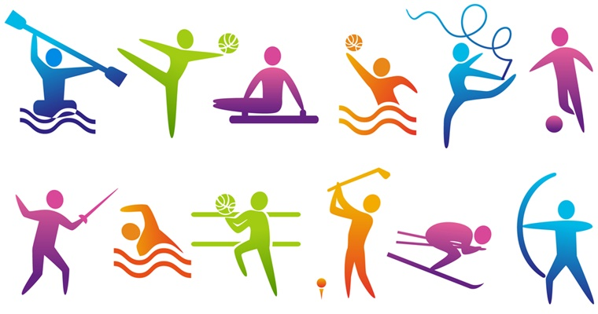
Please send us photos and videos of you and your family getting active, so we can share how we’re doing! Post on your Health Week TEAMS or use @Balbardie_PS on Twitter
Many thanks, Mr Jeffries

