|  |  |  |  |  |  |  |  |
| --- | --- | --- | --- | --- | --- | --- | --- |
|  | 9:00 – 9:30 |  | 10:00 – 11:00 |  | 11:30 – 12:00 |  | 1:00 – 2:30 |
| MONDAY  8th June | **No School** | | | | | | |
| TUESDAY  9th June | PE with Joe or another 30 min workout |  | * Olympic/Paralympic Values (Art) * I See, I Think, I Wonder |  | Travel To Tokyo Active Challenge (1) |  | Tokyo 10 Minutes X 4  PACK 1 |
| **Balbardie Virtual Sports Day Begins Wed 10th** | | | | | | | |
| WEDNESDAY  10th June | PE with Joe or another 30 min workout |  | * Olympic/Paralympic Values (Art) * Olympic Tracksuit |  | Travel To Tokyo Active Challenge (2) |  | Tokyo 10 Minutes X 3  PACK 2 |
| THURSDAY  11th June | PE with Joe or another 30 min workout |  | * Olympic/Paralympic Values (Art) * ChatterPix Mascot |  | Travel To Tokyo Active Challenge (3) |  | Tokyo 10 Minutes X 3  PACK 3 |
| FRIDAY  12th June | PE with Joe or another 30 min workout |  | * Tokyo 10 Minutes x 3   PACK 4 |  | * Olympic Quiz * Closing Ceremony Poster |  |  |
| **All results for virtual sports day must be submitted** | | | | | | | |

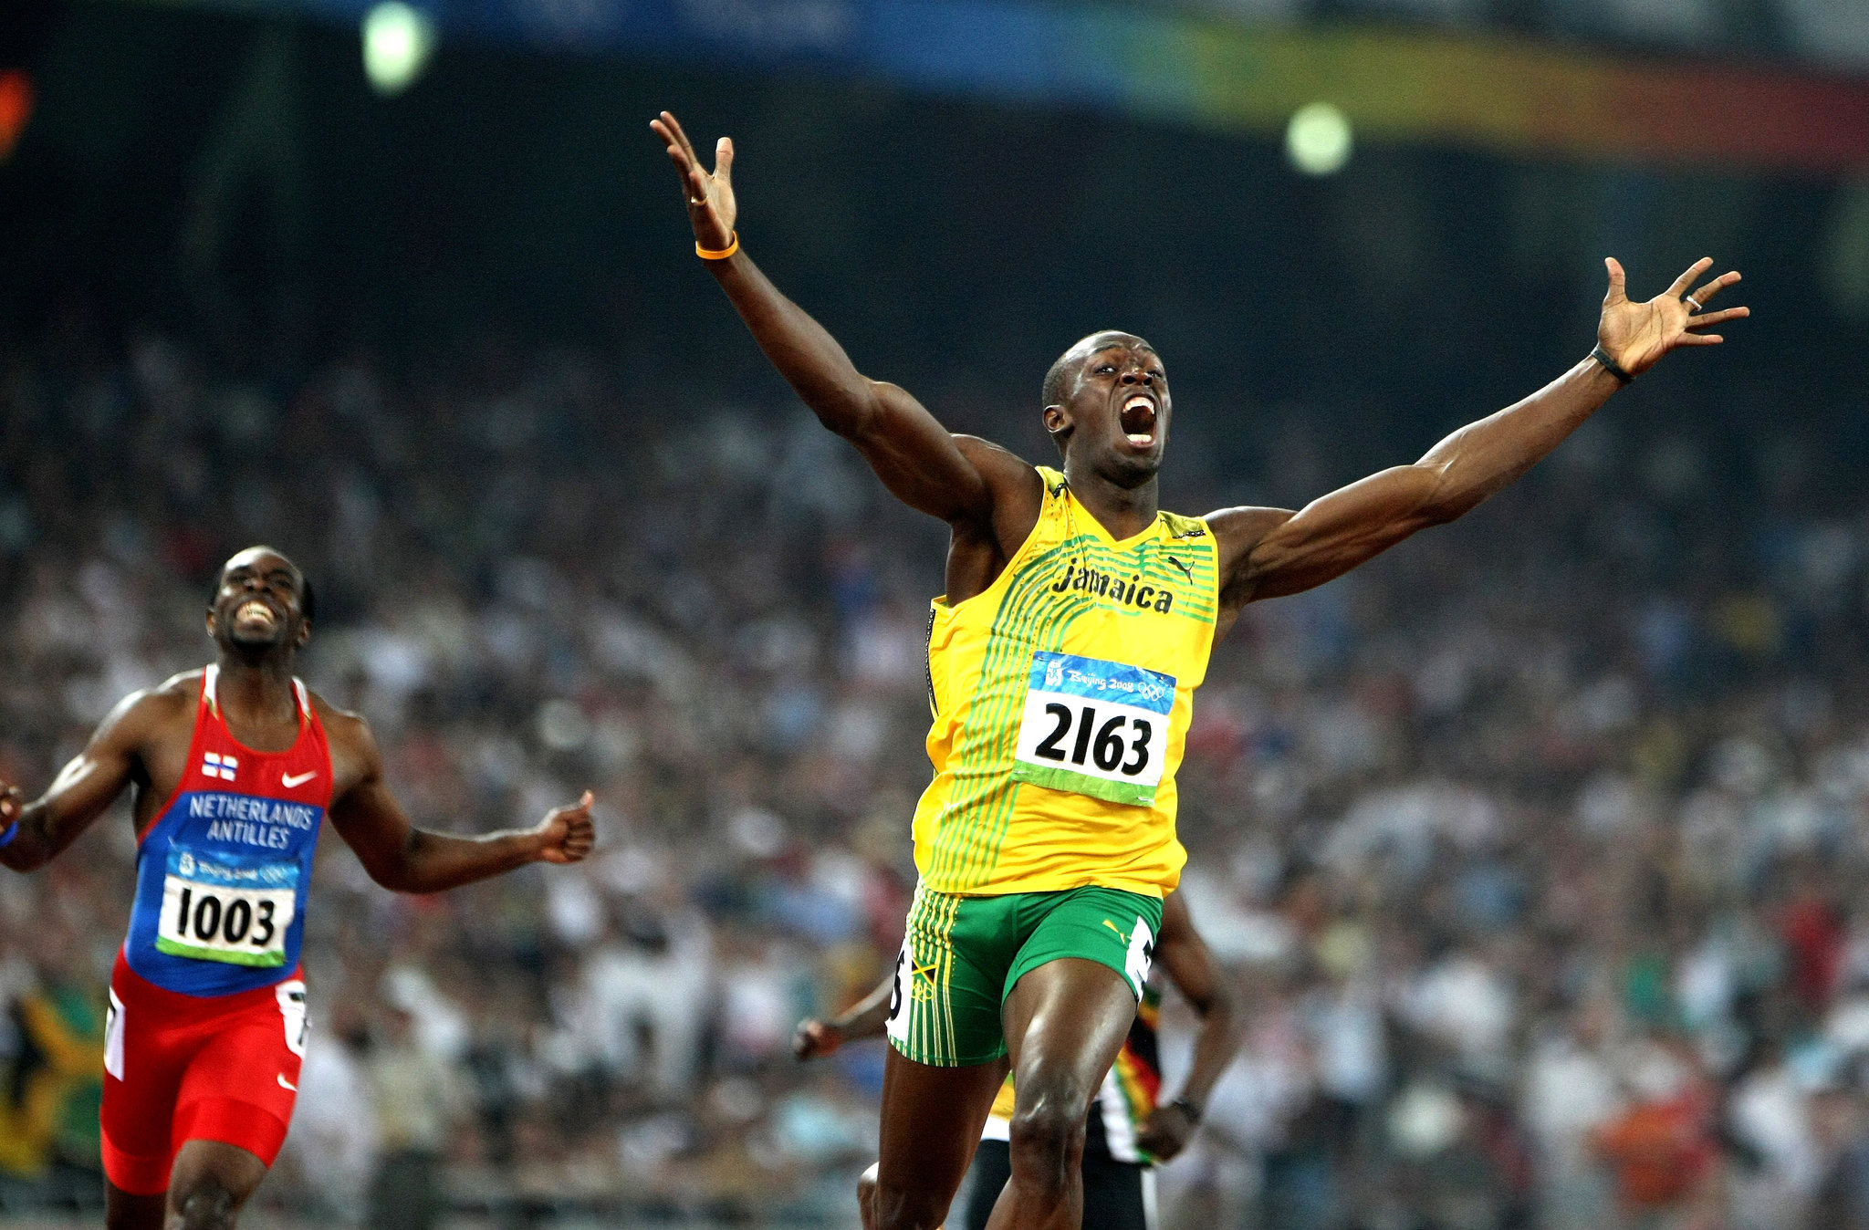

**TIMES ARE APPROXIMATE**

**LUNCH**

**BREAK**

**BREAK**