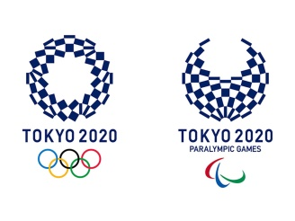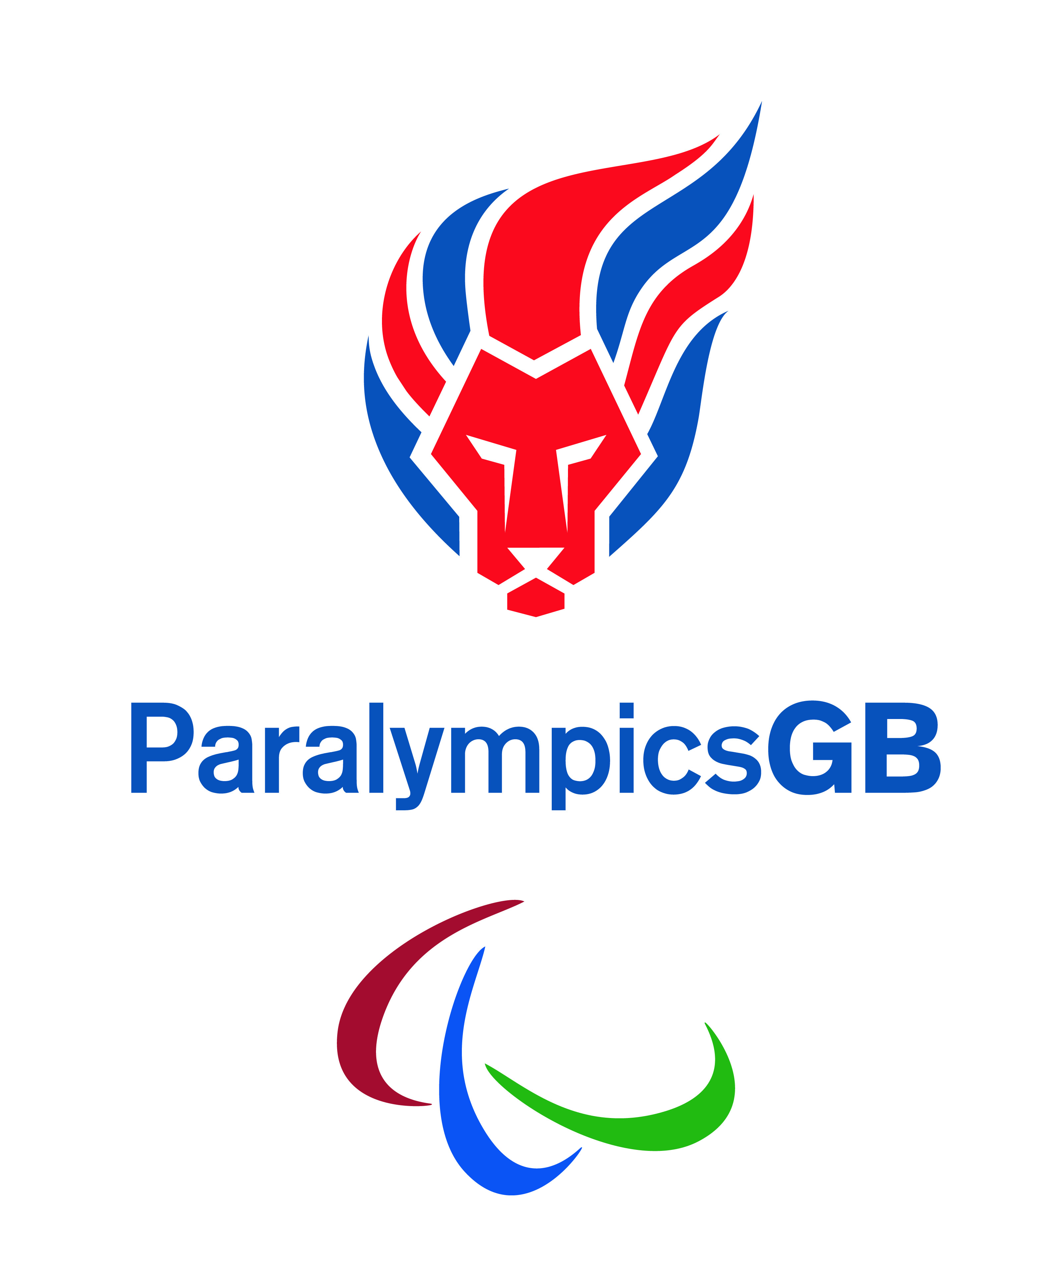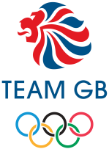**Draw or design a picture of yourself at an Olympic Closing Ceremony. You could be in the crowd, an athlete, or a performer.**