

BALBARDIE PRIMARY SCHOOL
BATHGATE EARLY YEARS CENTRE
SCHOOL IMPROVEMENT PLAN

2025 / 2026

Factors Influencing the Improvement Plan

School Factors
Recent Education Scotland Inspection (October 2024)
Recent Care Inspectorate Inspection of Early Years (June 2025)
New Senior Leadership Team
Addressing Action Points identified in school’s Self Evaluation procedures
Cluster Improvement Priorities
Equity Priorities

Local Authority Factors
Moving Forward in Your Learning Guidance
Literacy and Numeracy West Lothian Priorities, HWB
Raising attainment, including closing the gap (West Lothian Raising Attainment Strategy)
Transforming Your Council
Corporate Plan
Education Services Management Plan
West Lothian Parental Involvement and Engagement Framework
Equity Team and additional allocations, Pedagogy Team
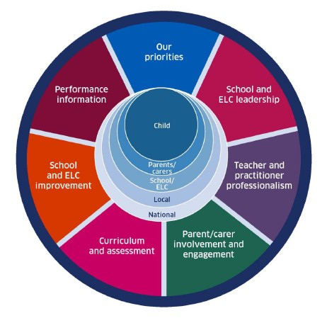
National Factors
Coronavirus (COVID-19): Guidance on reducing the risks from COVID-19 in school
Moderation Cycle and Assessment
National Improvement Framework / Scottish Attainment Challenge / National Improvement Hub / Raising Attainment for All
Pupil Equity Funding/Equity Audit
How Good is Our School? 4th Edition and How Good is Our Early Learning and Childcare?, National Standard for ELC, Quality Framework for day care of children
Getting it Right for Every child (GIRFEC)
Curriculum for Excellence Refresh
Realising the Ambition
Developing Scotland’s Young Workforce
Child Protection Procedures
GTCS professional standards and professional update 2021
Achieving Excellence and Equity 2022: National Improvement Framework and Improvement Plan
Putting Learners at the Centre: Towards a Future Vision for Scottish Education, The Ken Muir report, March 2022.
UNCRC
Presumption to provide education in a mainstream setting 2019
Support for Learning: All our Children and All their Potential (ASL Review) 2020

Vision, Values and Aims
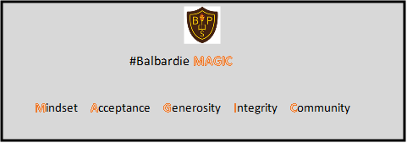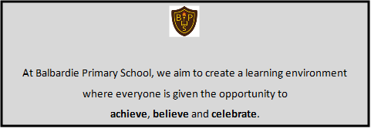

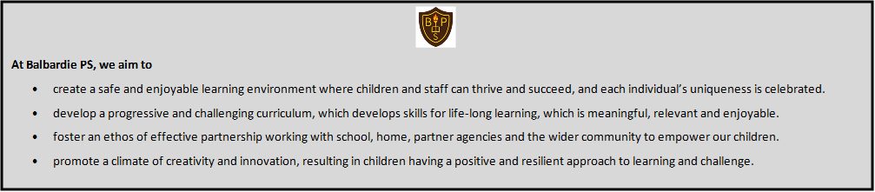

Curriculum Rationale

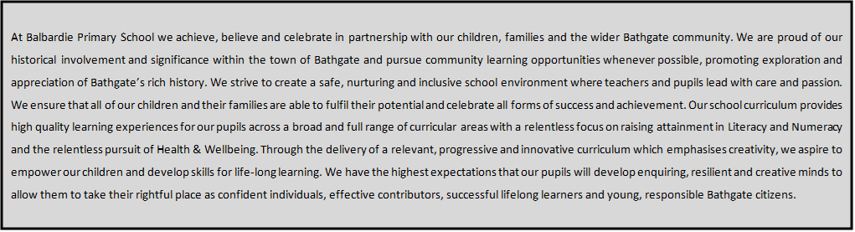

Background

We want all children at Balbardie Primary School to achieve, believe and celebrate. Therefore, we have the highest expectations of their learning and belief in their abilities. During the last academic session, there has been a continued focus on raising attainment for all in Literacy and Numeracy and improving the wellbeing of all pupils and their families. We have a clear and shared understanding of our strengths and areas for improvement which were guided by the Education Scotland inspection in October 2024. The staff team engage with partners regularly to ensure effective self-evaluation leads to school improvement and a consistently positive impact on pupil learning. The Head teacher, the Depute Head teacher and 4 Principal Teachers work alongside an energetic staff team of 24 teachers and 11 pupil support workers in the school and autism provision and 8 Early Years Practitioners and 2 Pupil Support Workers within the Early Years setting.

Data

Our school values the information that regular data analysis provides us. We use Impact Meetings and collegiate working to engage in continuous dialogue around this data to support interventions and improve attainment for all pupils. This data tells us that, overall, attainment in Literacy and Numeracy is continuing to improve over time. The majority of children in P1, P4 and P7 attain the appropriate CfE levels in Literacy and Numeracy. Data shows us clearly which stages of the school we need to target for universal supports in reading, writing and listening & talking. Our principal focus in Literacy this year will be to embed and continue recent improvements in tracking reading, writing listening and talking across all stages with a consistent and rigorous approach. This will ensure that staff are able to maintain appropritae pace for all children’s literacy learning and allow them to identify accurate next steps in learning. Our focus in Numeracy will be to continue to embed recent numeracy progressions and tracking. We will focus, alongside our cluster colleagues, on continuing to review our Positive Relationships Policy.
At most stages, our Quintile 1 learners are making good progress in both Literacy and Numeracy. We aim to further raise attainment for our Quintile 1 learners with intervention groups and support in class for individuals and groups. We will be supported in this throughout the year by the central Equity Team. Whole-school data show that we need to focus resources and support for those pupils who have very individual needs to allow them to access learning within their class and with their peers. Our Quintile 5 pupils are making good progress in Literacy and good progress in Numeracy at most stages.
The Health & Wellbeing data we collect from our pupil tracking shows most children reporting positively across each of the wellbeing indicators. We will continue to develop and embed our Health & Wellbeing curriculum and Focus Friday work by developing further opportunities for Pupil Voice.

Anywhere School - School Improvement Planning for Ensuring Excellence and Equity
School priorities linked to knowledge and data as identified on previous page | NIF Driver | Proposed actions | Timescale | Measures of Success
Improvement in all children and young people’s wellbeing:  Our children will be able to take part in regular Health and Wellbeing focused learner conversations.  Our children will be supported with their wellbeing and will know where to access support when they need it.  Our children will continue to be supported to build positive relationships with their peers and the adults around them in school.  Our children will be able to talk confidently about indicators of wellbeing.  Our children will experience inclusive practice across the school.  Our children will experience a consistent and progressive outdoor learning curriculum.  UNCRC 12, 14, 15, 19 | ☐School and ELC Improvement.  ☒School and ELC Leadership  ☒Teacher and Practitioner Professionalism  ☒Parental Engagement  ☒Curriculum and Assessment  ☒Performance Information | - Embed our refreshed Positive Relationships Policy / scripted language approaches to managing positive relationships in school.  - Consult on and refresh Trusted Adult approaches.  - Ensure that all children can talk confidently about Zones of Regulation and Emotion Works and how these approaches can support positive relationships and emotional regulation.  - Staff to continue to implement CIRCLE approaches in all areas of the school.  - Continue to work towards RRS Gold.  - Review our Outdoor Learning approaches and implement a progressive programme at all stages. | Oct 25  Nov 25  Oct 25  Jan 26  June 26 | - Evidence of staff confidence in implementing the Positive Relationships Policy  Measure : Staff and pupil feedback.  - Evidence of Trusted Adult approaches being used to support children’s wellbeing  Measures : Data will show the number of requests for access to Trusted Adults and evaluations will show the impact of those Trusted Adult conversations on children’s wellbeing.  - Evidence of progressive outdoor learning opportunities throughout the curriculum.  Measures : QI activity and Feedback from learners  - Evidence of the impact of CIRCLE approaches.  Measures: QI activity and staff evaluations
Raising attainment for all, particularly in literacy and numeracy(universal):  Our children will benefit from consistent apporaoches to Learning, Teaching and Assessment which will continue to raise attainment.  Our children’s progress in Literacy and Numeracy will be tracked effectively.  Continue to develop learner conversations and profiling in Literacy and Numeracy with all learners.  Our children will experience a progressive play-based curriculum at P1 and P2.  UNCRC 12, 28, 29 | ☒School and ELC Improvement  ☒School and ELC Leadership  ☒Teacher and Practitioner Professionalism  ☒Parental Engagement  ☒Curriculum and Assessment  ☒Performance Information | - To enhance data informed practice all staff will collaborate with WL Equity Team to build capacity in interpreting class and whole school quintile, attainment and wellbeing data.  - Continue to embed the revised Learning, Teaching & Assessment Blueprint in all classes  - Ensure all staff are implementing a 4-part lesson structure for all lessons which will determine appropriate pace.  - All teachers will consistently design, communicate and co-construct student friendly learning intentions and success criteria during every lesson.  - Work on ensuring differentiation in all lessons, utilising the PL offer from the Equity Team  - Continue to embed the use of newly developed trackers in Literacy and Numeracy  - Continue to develop play pedagogy in the infant classes, utilising the support of the central team. | Nov 25  June 26  June 26  June 26  Jan 26  Oct/Jan/May | - Evidence: All adults able to identify the poverty related attainment gap. Measure: Staff questionnaire  - Evidence of consisitency in learning, teaching and assessment in all classes.  Measure: QI activity.  - Children are able to speak confidently about their learning.  Measure: Completed learner conversations  - Children’s progress is tracked in all areas of Literacy and Numeracy on a termly basis which allows appropriate pace and identification of next steps.  Measure: Attainment data and QI activity
Tackling the attainment gap between the most and least advantaged children (targeted):  X state priority  UNCRC 6, 12, 24, 27, 28, 29 | ☒School and ELC Improvement  ☒School and ELC Leadership  ☒Teacher and Practitioner Professionalism  ☒Parental Engagement  ☒Curriculum and Assessment  ☒Performance Information | ‘All West Lothian schools are committed to continuously developing their approach to ensure equity and tackle the poverty related attainment gap. Each school’s PEF Summary provides an overview of their approach and an outline of how Pupil Equity Funding is being used to provide a range of universal and targeted approaches and interventions.  Please follow this link (INSERT HYPERLINK) to view our PEF Summary and find out more about our use of Pupil Equity Funding.’ |  | Documented in PEF Plan
Improvement in employability skills and sustained, positive school leaver destinations for all young people:  Our children will receive a broad and balanced curriculum at all stages.  Our children will be provided with opportunities to practice their metaskills at all stages.  Our children will experience an increased Pupil Voice in decision-making at whole school level.  UNCRC 13, 14, 15, 28, 29 | ☒School and ELC Improvement  ☒School and ELC Leadership  ☒Teacher and Practitioner Professionalism  ☒Parental Engagement  ☒Curriculum and Assessment  ☒Performance Information | - Implement Learning Councils which will allow all children to lead aspects of learning across the school.  - Creation of a Participatory Budget Committee to create parental/community engagement in planned PEF spend.  - Development of a metaskills progression that enables tracking of metaskills development and ensures comprehensive curriculum coverage.  - Update medium term forward planning processes to ensure efficient tracking of curriculum coverage. | September 25  Jan 26  Jan 26 | - Evidence that children are able to influence decision-making at whole school level through their involvement in Learning Councils.  Measure: Learner conversations, pupil evaluations of their own Learning Council action planning.  - Evidence demonstrates that all children experience a broad curriculum.  Measure: QI activity and pupil learner conversations.  - Evidence that cjildren are able to discuss the metaskills in relation to their learning.  Measure: Learner conversations, monitoring pupil work.

Bathgate Early Years Centre
ELC ACTION PLAN
TO SUPPORT DELIVERY OF SIP

2025 / 2026


Our Vision

At Bathgate Early Years Centre we strive to make every child feel important, providing a high quality learning environment where children are free to play, learn and develop together.

Our Values

Fun Kindness Encouragement Included Wellbeing Respect

Our Aims

- Value and respect everyone equally.
- Provide a safe, warm, welcoming, happy environment which stimulates curiosity, inquiry and creativity.
- Encourage each child to become a confident and independent learner.
- Celebrate learning and achievements both in nursery and from home.
- Ensure that each child is given a range of opportunities and learning experiences both indoors and outdoors, suitable for their learning needs.
- Encourage all children to develop socially and emotionally with wellbeing at the heart of everything we do.
- Ensure we are working with parents and all stakeholders in partnership.
- Celebrate and engage with our wider Bathgate Community.

DRAFT (Updating following CI June 2025)

Bathgate Early Years Centre - ELC Improvement Planning for Ensuring Excellence and Equity
School priorities linked to knowledge and data as identified on previous page | Links to HGIOELC and NH&SCS | Proposed actions | Timescale | Measures of Success
Improvement in all children and young people’s wellbeing:  To continue to build positive relationships with children and families to improve the health and wellbeing outcomes and tackle the attainment gap.  Continue to ensure that the needs of all children are reflected accurately within rigorous and thorough Personal Plans.  To embed the UNCRC and ensure children’s rights are central to every aspect of care, play and learning.  (Placing the human rights and needs of every child and young person at the centre of education) | 1.3  3.19 4.19, 4.23  1.1  4.19  2.2  1.20, 1.30, 1.31 | Review the vision, values and aims of the setting.  Continue to develop staff knowledge of the updated CI Quality Framework as a tool for self-evaluation.  Develop processes and systems to ensure all Personal Plans are up to date and shared effectively. Quality assurance processes will work alongside these systems to monitor quality and detail.  Develop staff knowledge and engagement with the newly introduced BPS HWB Progression.  Increase the profile of the rights of all children within the nursery setting and among families.  Working with WLC, ensure policy and processes are in place to uphold the rights of all children in the event of incidents. | Nov 2024  Dec 2024  Oct 24  Jan 2025 | Observations of playroom and interactions show the vision, values and aims of the setting in action.  Increase in staff knowledge of use of framework  All children will have a Personal Plan which accurately reflects their physical and learning needs.  Staff engagement with the BPS Early Level Progression. Evidence of children learning through their rights.  All children’s rights will be upheld in the event of any incident or allegation.
Raising attainment for all, particularly in literacy and numeracy(universal):  All children will benefit from focussed work to develop and improve children’s literacy skills from the earliest stages, building early vocabulary skills.  All children will benefit from focussed work to develop and improve numeracy skills from the earliest stages.  To continue to develop practitioner knowledge of how to plan for children’s curiosity, creativity and enquiry to support purposeful play and learning.  (Placing the human rights and needs of every child and young person at the centre of education) | 2.2, 2.3, 2.5 & 3.2  1.27 & 1.30  2.3 & 3.2  1.27 & 1.30  2.2, 2.3  1.25, 1.30 & 1.32 | Continue to develop the pre requisite skills for reading: listening attention, awareness of rhythm and concepts of print through responsive and intentionally planned experiences.  Continue to develop staff knowledge and use of Early Level Numeracy Progression Pathways as a tool to support planning and assessment. Use of pathway to support differentiated learning.  Continue to develop the use of focused observations linked to the planning, assessment and moderation cycle to support practitioner judgements and ensuring coverage of the curriculum.  Continue to develop the use of intentionally planned experiences to support children’s learning through purposeful play and learning experiences. | Ongoing  Ongoing  Ongoing  Ongoing | Pupil Progress data/practitioner judgements/quality observations  Use of the progression pathway will be evident in planning.  Clear links between planning, observations and trackers.  Practice observation show clear planning linked to assessment and observations  Quality assurance evidence – practice observations, planning and learning journals.  Professional dialogue feedback  Environmental audit tools  HGIOPfL audit
Tackling the attainment gap between the most and least advantaged children (targeted):  Provide focussed work to develop and improve children’s literacy and numeracy skills and HWB from the earliest stages  (Placing the human rights and needs of every child and young person at the centre of education) | 2.4  1.27 & 1.29 | Continue to support identified children through targeted literacy, numeracy and wellbeing interventions. | From Oct 2024 | Pupil Progress data/practitioner judgements/quality observations

